# **10 reasons why you should study Social Work**

In honour of National Social Work Day, we had a chat with BSc (Hons) Social Work student, Jessica Tout, to find out just 10 of the reasons why you should consider studying Social Work.



#### **1. You will learn how to make a positive impact**

Social Work is all about understanding and striving to improve the lives of people in society. Social Workers listen to people's needs, from young children to people struggling with addictions, and help them to cope and improve their quality of life. This course has enabled me to understand how to make a positive impact in society and has made me aware of how quickly your circumstances in life can change.

#### **2. There are many job options**

A degree in Social Work will provide me with the ability to undertake a variety of different professional roles. These roles include working with child protection, older people, in hospitals or in the fostering sector. These are just a few examples of the roles available within this sector.

#### **3. You can gain transferable skills**

Skills that I will develop throughout my degree will be valued by many employers. Skills such as how to communicate with a client, problem solving, empathy, team work and time management can be transferred to many different roles within the Social Work sector and other careers.

#### **4. The world needs social workers**

There will always be people in need, so there will always be a demand for those who are educated in the subject area, meaning jobs shouldn't be too difficult to find and you will always be able to make a positive impact!

[Visit our course page for more information](https://www.bcu.ac.uk/education-and-social-work/courses/social-work-bsc-hons-2019-20)

#### **5. It will teach you things you never knew about yourself**

The situations Social Work will put you in are unique and often extreme. The course has helped me understand how to cope in certain situations. You may learn that you are an expert in dealing with aggressive behaviour or you might learn how to cope with your own emotions at the end of a difficult day. You will learn your different strengths and weaknesses and find that this course teaches you things about yourself that you didn’t know before.

#### **6. You will meet like-minded people**

The course has allowed me to meet people who want to make a difference and stand up for people’s rights. I have met a diverse range of students who have all come together to make a change and who want to make a real impact on someone’s life. Not every course can offer that.

#### **7. Great opportunities**

The course has offered me some great opportunities such as shadowing qualified Social Workers, resiliency days, trips abroad and a wide range of placement options for my second and third year.

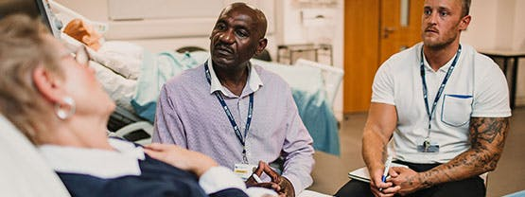

#### **8. It teaches you the true value of things**

The Social Work course has shown me some of the most upsetting sides of humanity and there will be times when it can seem hard to remove yourself from it. But I have begun to notice the good in people that previously I took for granted. I became extremely grateful for all that I have and realised that true wealth does not come from material things.

#### **9. The lectures and lecturers**

The lecturers at BCU are excellent, their knowledge on Social Work is exceptional, and they are all there to help answer any questions you may have. They all have a range of experiences which they're willing to share, which makes their lectures interesting and very informative. The lectures are engaging too and have given me a strong understanding of Social Work.

#### **10. Simulation facilities**

The final module in year one is aimed at ensuring that I have the correct skills when working with service users. This module has allowed me to work in the simulation rooms which are set up as living rooms and hospital wards. These facilities are full of fantastic technology and are really useful when I want to practise skills ready for my placements.